BÁO CÁO ASSIGNMENT 3

Tháng 10 năm 2022

Trường Đại học Công nghệ Thông tin

Lớp CS410.N11

Huỳnh Hoàng Vũ - 20520864

f = Sphere, d = 2

| pop_size | CEM | DE |
| --- | --- | --- |
| 32 | 0.0 (0.0) | 0.0 (0.0) |
| 64 | 0.0 (0.0) | 4.931e-280 (2.457e-279) |
| 128 | 2.577e-236 (6.643e-236) | 8.433e-142 (3.852e-141) |
| 256 | 9.347e-119 (1.526e-118) | 7.705e-72 (2.405e-71) |
| 512 | 2.327e-60 (3.262e-60) | 3.581e-37 (6.813e-37) |
| 1024 | 4.099e-31 (8.492e-31) | 9.249e-20 (2.538e-19) |

f = Sphere, d = 10

| pop_size | CEM | DE |
| --- | --- | --- |
| 32 | 3.463e-207 (2.703e-207) | 0.0 (0.0) |
| 64 | 1.338e-100 (1.012e-100) | 2.713e-299 (1.226e-298) |
| 128 | 3.542e-49 (3.258e-49) | 5.886e-146 (2.609e-145) |
| 256 | 4.843e-24 (3.098e-24) | 2.416e-72 (4.130e-72) |
| 512 | 1.06e-11 (4.694e-12) | 1.171e-35 (1.015e-35) |
| 1024 | 1.343e-05 (8.727e-06) | 1.439e-17 (8.509e-18) |

f = Zakharov, d = 2

| pop_size | CEM | DE |
| --- | --- | --- |
| 32 | 0.0 (0.0) | 0.0 (0.0) |
| 64 | 0.0 (0.0) | 9.032e-261 (4.591e-260) |
| 128 | 7.96e-236 (1.62e-235) | 1.366e-131 (4.808e-131) |
| 256 | 3.921e-118 (8.738e-118) | 4.158e-66 (1.248e-65) |
| 512 | 8.041e-60 (1.39e-59) | 1.553e-33 (4.613e-33) |
| 1024 | 1.01e-30 (2.449e-30) | 1.293e-17 (2.111e-17) |

f = Zakharov, d = 10

| pop_size | CEM | DE |
| --- | --- | --- |
| 32 | 6.012e-164 (1.363e-163) | 6.756e-191 (3.1e-190) |
| 64 | 4.632e-75 (5.535e-75) | 1.593e-87 (4.228e-87) |
| 128 | 6.503e-35 (9.363e-35) | 8.685e-41 (1.963e-40) |
| 256 | 4.595e-16 (6.516e-16) | 1.085e-18 (1.991e-18) |
| 512 | 4.426e-07 (3.037e-07) | 7.617e-08 (3.793e-08) |
| 1024 | 0.0145 (0.0108) | 0.01334 (0.0079) |

f = Rosenbrock, d = 2

| pop_size | CEM | DE |
| --- | --- | --- |
| 32 | 0.1665 (0.6646) | 0.0 (0.0) |
| 64 | 0.0262 (0.091) | 0.0 (0.0) |
| 128 | 0.0241 (0.0637) | 0.0 (0.0) |
| 256 | 0.0154 (0.0475) | 0.0 (0.0) |
| 512 | 0.0044 (0.0129) | 2.05e-15 (6.36e-15) |
| 1024 | 0.0032 (0.0088) | 4.236e-07 (7.896e-07) |

f = Rosenbrock, d = 10

| pop_size | CEM | DE |
| --- | --- | --- |
| 32 | 8.665e-28 (7.805e-28) | 0.0 (0.0) |
| 64 | 3.541e-27 (2.383e-27) | 0.0 (0.0) |
| 128 | 1.045e-22 (2.781e-22) | 2.206e-23 (2.764e-23) |
| 256 | 5.667e-10 (7.604e-10) | 9.009e-11 (8.341e-11) |
| 512 | 0.00562 (0.00452) | 0.00018 (0.00013) |
| 1024 | 4.7958 (0.4828) | 0.4373 (0.1328) |

f = Michalewicz, d = 2

| pop_size | CEM | DE |
| --- | --- | --- |
| 32 | -1.8013034100985539 (9.128167018299422e-16) | -1.8013034100985539 (7.021666937153401e-16) |
| 64 | -1.8013034100985539 (7.021666937153401e-16) | -1.8013034100985539 (7.021666937153401e-16) |
| 128 | -1.8013034100985539 (7.021666937153401e-16) | -1.8013034100985539 (7.021666937153401e-16) |
| 256 | -1.8013034100985539 (7.021666937153401e-16) | -1.8013034100985539 (7.021666937153401e-16) |
| 512 | -1.8013034100985539 (7.021666937153401e-16) | -1.8013034100985539 (7.021666937153401e-16) |
| 1024 | -1.8013034100985539 (7.021666937153401e-16) | -1.8013034100985539 (9.830333712014763e-16) |

f = Michalewicz, d = 10

| pop_size | CEM | DE |
| --- | --- | --- |
| 32 | -8.4394 (1.4714) | -9.6397 (0.0616) |
| 64 | -9.1064 (0.6405) | -9.6518 (0.0423) |
| 128 | -9.2893 (0.9044) | -9.6602 (0.0) |
| 256 | -9.4184 (0.436) | -9.6602 (0.0) |
| 512 | -9.3957 (0.2874) | -9.6602 (1.2419e-06) |
| 1024 | -9.0093 (0.5635) | -9.291 (0.1825) |

f = Ackley, d = 2

| pop_size | CEM | DE |
| --- | --- | --- |
| 32 | 0.0 (0.0) | 0.0 (0.0) |
| 64 | 0.0 (0.0) | 0.0 (0.0) |
| 128 | 0.0 (0.0) | 0.0 (0.0) |
| 256 | 0.0 (0.0) | 0.0 (0.0) |
| 512 | 0.0 (0.0) | 0.0 (0.0) |
| 1024 | 1.0303e-14 (1.483e-14) | 5.8588e-09 (8.306e-09) |

f = Ackley, d = 10

| pop_size | CEM | DE |
| --- | --- | --- |
| 32 | 3.553e-15 (0.0) | 2.132e-15 (5.393e-15) |
| 64 | 3.197e-15 (2.022e-15) | 3.553e-15 (0.0) |
| 128 | 2.842e-15 (3.595e-15) | 2.487e-15 (4.719e-15) |
| 256 | 1.976e-11 (6.166e-12) | 3.197e-15 (2.022e-15) |
| 512 | 2.946e-05 (7.1899e-06) | 3.553e-15 (0.0) |
| 1024 | 0.037 (0.012) | 4.343e-08 (1.856e-08) |

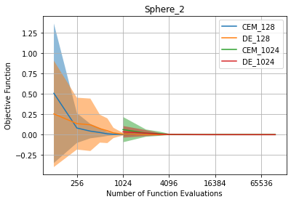

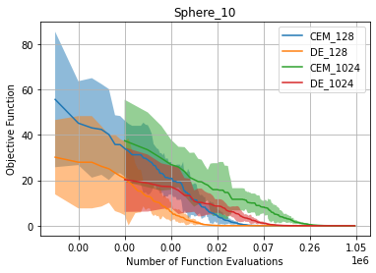

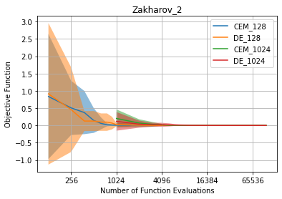

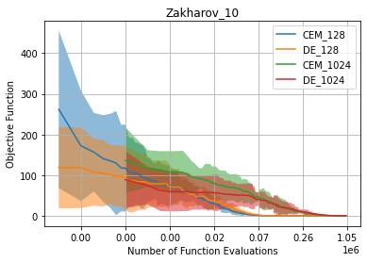

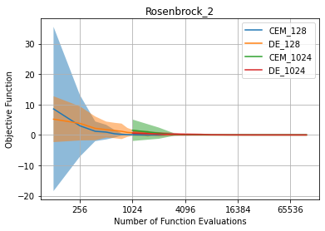

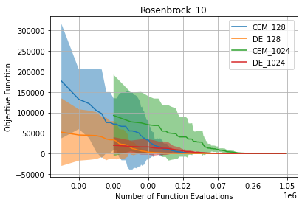

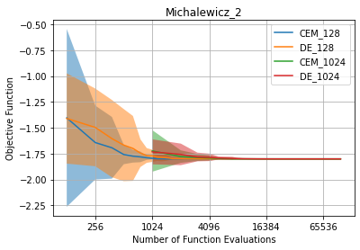

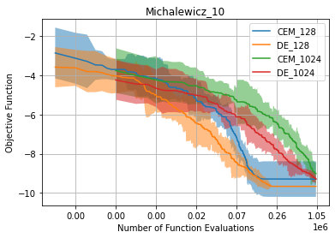

Nhận xét:

CEM có nhiều trường hợp tốt hơn DE và ngược lại. CEM có 16 trường hợp tốt hơn DE, DE có 23 trường hợp tốt hơn CEM. Nhìn chung, DE tốt hơn CE.